COT3100 Spring’2002
Assignment #3
Assigned: 02/21−25, due: 03/7−18 in lecture.
Induction. Combinatorics.
Indicate your name, SSN and your recitation section number.

1. Prove by induction on n≥ 1 that
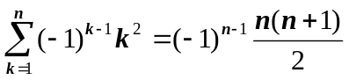

2. Prove that for any n ≥ 2, 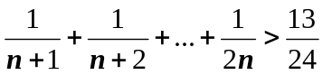

3. The Fibonacci numbers, f₀, f₁, f₂, …, are defined recursively by f₀ =0, f₁ = 1, and
f_{n} = f_{n−1} + f_{n−2} for n ≥ 2. Prove by induction that for any n ≥ 1
- gcd ( f_{n} , f_{n+1}) = 1.
- f₁ + f₂ + f₃ +…+ f_{n} = f_{n+2} − 1.

4. Use mathematical induction to prove that for any n≥ 1, 10^{n+1}+10^{n}+1 is divisible by 3.

5. Define a sequence the sequence {a_{n}} by a₁ = 1, a₂ = 0 and for n>2, a_{n} = 4⋅a_{n −1} − 4⋅a_{n −2}.
Prove that a_{n} = 2^{n}⋅(1− n/2) for all n ≥ 1.

6. Prove by induction that (2n)!<(n!)²4^{n −1} for every integer n≥5.

7. a) In how many ways can five different mathematics books, three different physics books, and four different chemistry books be arranged on a shelf ?
b) Repeat a) if all books of the same subject are to be together.
- Repeat a) if three of the five mathematics books are the same (not distinguishable).
- Repeat c) if, in addition, all the physics books are the same.

8. Consider a set A = {1, 2, 3, … , 10}.
- How many subsets of A contain all even integers in A?
- How many subsets of A contain exactly two even integers and two odd integers?
- How many 3-element subsets of A have the greatest element greater then 5?
- How many subsets of A contain not equal amount of even and odd numbers?

9. a) In how many ways can ten red balls, ten white balls, and ten blue balls be placed in 60 different boxes, at most one ball to a box?
b) In how many ways can ten red balls, ten white balls, and ten blue balls be placed in 60 different boxes?

